**Create an Azure Active Directory B2C tenant**

Before your applications can interact with Azure Active Directory B2C (Azure AD B2C), they must be registered in a tenant that you manage.

In this article, you learn how to:

* Create an Azure AD B2C tenant
* Link your tenant to your subscription
* Switch to the directory containing your Azure AD B2C tenant
* Add the Azure AD B2C resource as a **Favourite** in the Azure portal

1. Sign in to the [Azure portal](https://portal.azure.com/). Sign in with an Azure account that's been assigned at least the [Contributor](https://docs.microsoft.com/en-us/azure/role-based-access-control/built-in-roles) role within the subscription or a resource group within the subscription.
2. Select the directory that contains your subscription.

In the Azure portal toolbar, select the **Directory + Subscription** icon, and then select the directory that contains your subscription. This directory is different from the one that will contain your Azure AD B2C tenant.

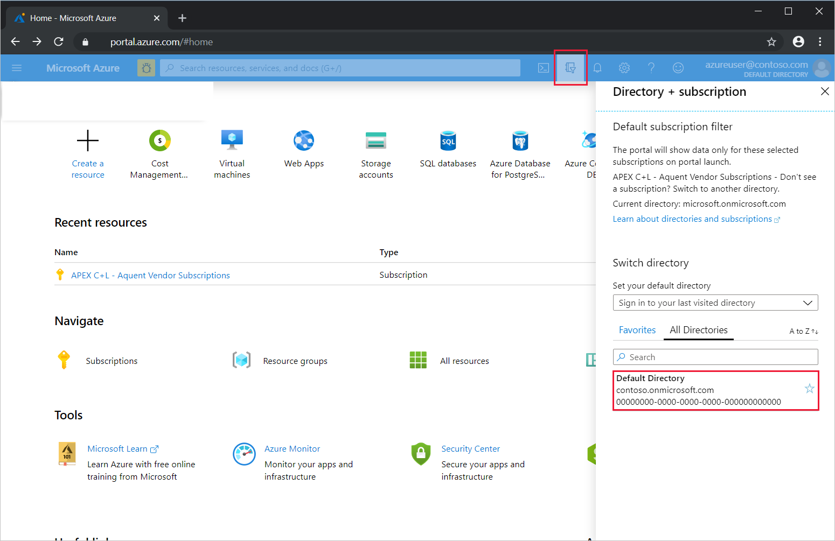

1. On the Azure portal menu or from the **Home** page, select **Create a resource**.

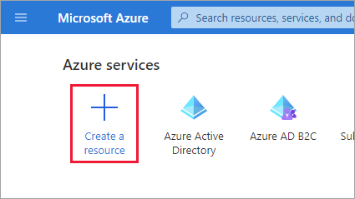

1. Search for **Azure Active Directory B2C**, and then select **Create**.
2. Select **Create a new Azure AD B2C Tenant**.

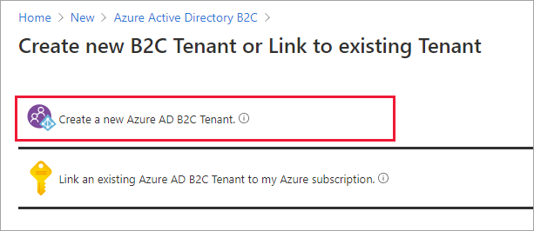

1. On the **Create a directory** page, enter the following:
   * **Organization name** - Enter a name for your Azure AD B2C tenant.
   * **Initial domain name** - Enter a domain name for your Azure AD B2C tenant.
   * **Country or region** - Select your country or region from the list. This selection can't be changed later.
   * **Subscription** - Select your subscription from the list.
   * **Resource group** - Select or search for the resource group that will contain the tenant.

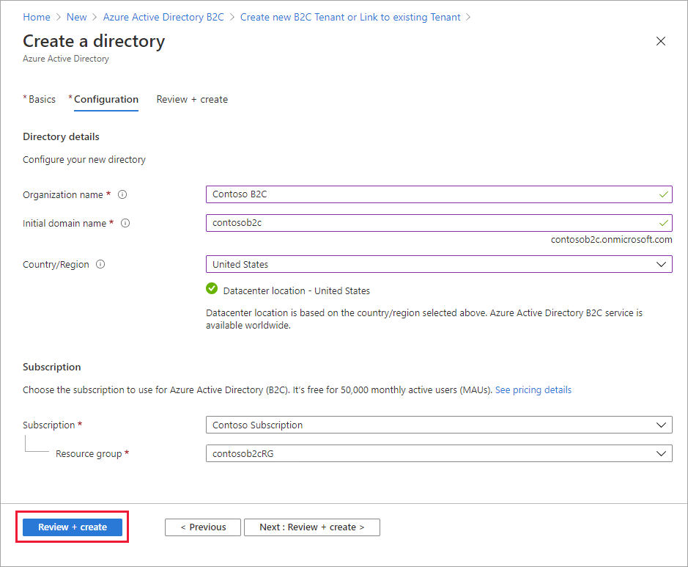

1. Select **Review + create**.
2. Review your directory settings. Then select **Create**.

You can link multiple Azure AD B2C tenants to a single Azure subscription for billing purposes. To link a tenant, you must be an admin in the Azure AD B2C tenant and be assigned at least a Contributor role within the Azure subscription. See [Link an Azure AD B2C tenant to a subscription](https://docs.microsoft.com/en-us/azure/active-directory-b2c/billing#link-an-azure-ad-b2c-tenant-to-a-subscription).